**Nelson Mandela: *Behold* this Phoenix Rising**

Nelson Mandela is—after Mahatma Gandhi whom he initially emulated—**one of the best-known names in recent history.** Most of us recognize him in the image of this aged, courtly, white-haired man with the benevolent smile. After all, he lived to be 95 … and made an unforgettably positive impact on the life of an entire nation and its 60 million—mostly Black—people.

But what of the ***Phoenix*** that had arisen? His story is most dramatic; let’s take a look, starting with the socio-political background.

***From rural cattle-herder***

***… to firebrand “freedom fighter”***

***… to prisoner for life***

***… to post-apartheid President!***

***A near-century of self-transcendence***

***\*\*\*\*\*\*\*\*\*\*\****

**South Africa’s Apartheid**

**Apartheid.** “Separateness” in the Afrikaans language—Apartheid was a “system of institutionalized racial discrimination and segregation” that existed in South Africa from 1948 to the early 1990s.

But its exploitive roots descend much deeper, back to the 17th century European colonization of the southern part of the African continent. The Dutch Boer-based authoritarian political culture took pains to ensure that South Africa was politically, socially and economically dominated by the nation's small white minority. In the 20th century, although apartheid actively interfered with accurate data collection, it is evident that the South African population percentage of Blacks increased to over 75% during the reign of Apartheid while the percentage of Whites declined from 20% to only 13%. Yet they ruled with an iron fist and scant trace of compassion. On the contrary.

Into this oppression, an obscure black boy-child was born.

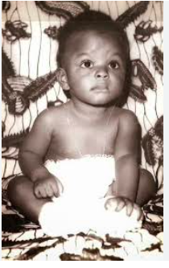**The Making of a true “Troublemaker”**

The child who later became the “grandfather of his nation” was born the son of an illiterate local African chieftain who died when he was only nine years old. But despite this early childhood loss, Destiny was already at work. The boy was taken into the royal family of Jongintaba, King of the Thembu people, to become counselor to the king’s own son.

**An Emerging Leader with Six Successive Names …**

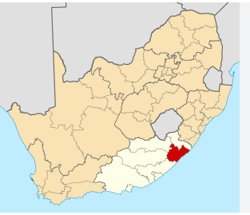Actually ‘Nelson’ was not his original name! He was born ‘Rolihlahla’ Mandela on July 18, 1918 in the village of Mvezo in a rural area of South Africa called Transkei.

* **“Rolihlahla”** was a tribal Xhosa name that means “pulling the branch of a tree” but also translates as “troublemaker”! Was he that? You tell *me!* Later as he grew, he acquired other names and nicknames.
* **“Nelson”** was the name given to him on his first day at school by his teacher because it was easier for the English colonials to pronounce.
* **“Dalibhunga”,** ‘creator or founder of the council’, was the name bestowed upon him at age 16 during traditional ‘rites of passage’ (i.e. circumcision).
* **“Madiba”,** another name, referred to the Thembu clan to which he belonged and, later still, as he acquired increasing renown, he was called:
* **“Tata”** and **“Khulu”,** Xhosa terms of deferential endearment that mean “father” and “grandfather”. And, of course,
* **“President** of South Africa” became his official title.

***Mandela in a Nutshell. Timeline and Ten Salient Facts!***

**1918.** Rolihlahla Mandela is born on 18 July in Mvezo, a tiny rural village in the Transkei in South Africa’s East Cape. Youngest child in a multi-generational patchwork family, they all grow up dirt poor. His father dies when he is only nine; he goes to live with his uncle, local Xhosa chieftain Jongintaba, who makes it possible for him to pursue higher education.

1. *Son of a tribal king, he is destined to become South Africa’s first black President;*
2. *He loves sports, believing they have the power to change the world;*
3. *He’s a great dancer and marries three times, the last at age 80!;*

**1941-44.** At 23, Nelson runs off to Johannesburg and there collides with the harsh racial face of ***apartheid—***racial segregation—and the discrimination implicit in this. In **1944.** Mandela (26) forms the ANC Youth League and his political activities accelerate, but at the same time, he marries a pacifist nurse. The seeds of moral conflict are sown.

1. *All told, Nelson fathers six children who produce 17 grandchildren;*
2. *He becomes an AIDS activist (one of his sons died of AIDS);*
3. *His favorite dish is—Ugh! Something you wouldn’t dream of (tripe)!;*

**1944 -58.** Mandela’s first marriage, to Evelyn Ntoko Mase, a Jehovah’s Witness, produces four children, but his political “calling”, plus his ever more violent activities, not to mention his marital infidelities, strain the relationship beyond repair. They divorce in 1958.Scarcely three months later, Nelson marries the pretty, far younger Winnie Madikizela, an equally committed anti-apartheid activist.

1. *He is a charismatic, radical ANC political activist who ends up spending 27 years in prison before finally being unconditionally freed.*

**1952-62** After opening South Africa’s first black law practice together withOliver Tambo, Mandela becomes not only a practicing lawyer, but also, increasingly, a well-known, if hot-headed, political activist.

**1962.** Mandela (44) is arrested and—irony of Fate or Destiny calling?—is ***not*** hanged as expected, but sentenced to **life imprisonment** for his anti-apartheid activism. Winnie is but 28 at the time and with two very young daughters to care for.

1. *These years in prison, exacerbated by painful personal loses, do not break, but instead fine-tune and temper him; not only that, to top it off;*

**1990.** Mandela, now 71, is freed without conditions, ending 27.5 years of political imprisonment.

**1993.** He and South Africa’s President F.W. de Klerk are jointly awarded the 1993 Nobel Prize for Peace “for their work for the peaceful termination of apartheid and laying the foundations for a new democratic South Africa”;

1. *Mandela becomes President of South Africa from 1994–1999. He intentionally does not run for a second term.*

**1998-2013.** Now, at 80, Mandela marries Graça Machel, the widow of [Samora Machel](https://www.britannica.com/biography/Samora-Machel), former president of Mozambique (1975–86); she is Mandela’s wife at his death in June 2013.

1. *His name lives on today on streets; squares, schools, airports and you-name-it that have been named after him; also everything exotic from nuclear particles to prehistoric woodpeckers to fragile orchids—and, of course, any number of newborn children named “Nelson”! Source:* [*https://www.capetowndiamondmuseum.org/blog/2019/07/5802/*](https://www.capetowndiamondmuseum.org/blog/2019/07/5802/)

***1. From “royal” child cattle-herder …***

**Early Years.** Mandela’s early life was infused with traditional Xhosa customs.

As the youngest of 13 children—his father was a polygamist with four wives—he experienced love in abundance. Talk about extended family! Both his mother and three stepmothers doted on him as if he were their own and his half-siblings treated him as if all were full-blooded family. Growing up, he tended cattle herds and spent his time mostly outdoors with the other boys.

Although his parents were illiterate, his devoutly Christian mother sent him to a church school where his teacher gave him the name the "Nelson" because it was easier for her to pronounce. In fact, Nelson was the very first to attend school and, when his father died of TB at only 44, Nelson said he felt he had inherited his father's "proud rebelliousness" and "stubborn sense of fairness".[[](https://en.wikipedia.org/wiki/Nelson_Mandela#cite_note-FOOTNOTEMandela19948,_20-20)

Perhaps. In any case, this precocious young boy was adopted by the Thembu chieftain who helped pave the way for his further education. Thus, Mandela made it through secondary school and was pursuing his BA at the University College of Fort Hare—when he was expelled for joining a student protest. When the king heard of this, he vented his fury, threatening to “arrange wives for them”. It was then that Nelson and his cousin Justice “ran away to Johannesburg instead”, arriving there in 1941, right in the thick of things.

But Destiny was at work because it was there that Nelson met Walter Sisulu, who would become a mentor, close friend and more, helping him to complete his BA … as well as to meet his first wife, Evelyn.

**Nelson’s Wives and their Contributions to his Life and Legacy.**

“Behind every great man there stands a great(er) woman” is a quote we often hear. Mandela had his share and, according to https://totallyhistory.com/nelson-mandelas-wives/, each wife brought something special to their union.A group of people posing for a photo

* **Evelyn Ntoko Mase** (married 1944–58). A gentle, early-orphaned Xhosa girl who became a nurse and, later, a Jehovah’s Witness, she later said that she “fell in love with him at first sight” and they married soon after. She bore him four of his six children. But problems arose over religion; as Nelson’s activism became more aggressive, he opposed her Jehovah’s Witness faith that, he said, “taught passivity and submissiveness in the face of oppression.” Once he met his future (second) wife, Winnie—the story went that Nelson had “discovered” her standing at a bus stop—his first marriage abruptly ended. 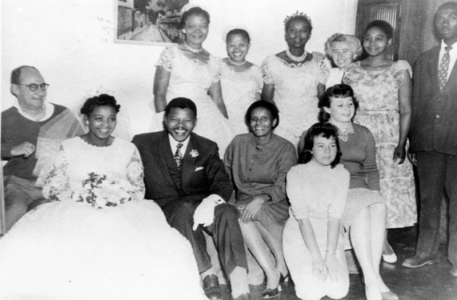
* [Winnie Madikizela-Mandela](https://www.britannica.com/biography/Winnie-Madikizela-Mandela) (married 1958 –96). A controversial activist and anti-[apartheid](https://www.britannica.com/topic/apartheid) champion in her own right, Winnie was twenty two when she met Nelson, sixteen years her senior and already a famous anti-apartheid figure and key defendant in the 1956 “treason trial”. They married in 1958, a scant three months after Nelson’s divorce from Evelyn. Winnie bore him two daughters, Zenani and Zindziwa, but Nelson’s life imprison-ment” sentence rendered her unable to deal with her ordeal. She became enmeshed in corruption, never mind her multiple romantic liaisons. After Nelson was freed, he was the one who finally filed for divorce in 1996. But his love life was not yet over.
* A person and person smiling

  Description automatically generatedGraça Machel (1998–2013). The widow of the former President of Mozambique, [Samora Machel](https://en.wikipedia.org/wiki/Samora_Machel) (1975–1986), Graça was already an international advocate for women's and children's rights and had been made an honorary [Dame Commander of the Order of the British Empire](https://en.wikipedia.org/wiki/Dame_Commander_of_the_Order_of_the_British_Empire) by Queen [Elizabeth II](https://en.wikipedia.org/wiki/Elizabeth_II) in 1997 for her humanitarian work. She is the only woman in modern history to have served as First Lady of two countries, South Africa and [Mozambique](https://en.wikipedia.org/wiki/Mozambique). She was Mandela’s wife at the time of his death in 2013.

***2. … to firebrand “freedom fighter”***

***The iconic black activist who*** *dedicated his life to dismantling racism in South Africa*

Initially—impressed by the non-violent methods of India's Mahatma Gandhi and supported by his pacifist, Jehovah Witness first wife, Evelyn—he studied law but, during the 1960s, became ever more the “hot-headed” political activist and swashbuckling “freedom fighter”.

It was during this fiery political period that he became known as the “black pimpernel” and spent some 17 moths in hiding. During this time—that coincided with his marriage to activist Winnie Madikizela—his aspiration was to dismantle the white minority rule under which blacks were denied political rights and basic freedoms.

His increasing inclination towards violence as the leader of the armed wing of the African National Congress included a bombing campaign against government targets that ultimately led to his imprisonment for more than a quarter-century. In this sense, his imprisonment may have “saved him from himself”.

According to the Nelson Mandela Foundation, he was arrested on multiple occasions and stood trial four times. He spent over 27 years in prison. Most important moments: --

* **1957-1961.** After a 4.5-year trial, where scores of people were charged with high treason, Mandela and the 27 remaining accused were acquitted. Known now as the “Black Pimpernel”. he went into hiding underground for some 17 months.
* **November 1962**. He is sentenced to five years in prison for incitement and leaving the country illegally.
* **October – November 1963.** Rivonia Trial. Together with ten others, Mandela is convicted of sabotage; all face the death penalty. On **12 June 1964** Mandela and seven others are sentenced to life imprisonment. He is released only on **11 February 1990 after 27.5 years.**

***Real leaders must be ready to sacrifice all***

***for the freedom of their people.”***

***-* Nelson Mandela, 25 April 1998**

***3. … to prisoner for life (or until death)***

In 1963 Mandela (45) was tried along with ten others for sabotage in what became known as the Rivonia Trial. Facing the death penalty (by hanging), his "Speech from the Dock" on 20 April 1964 became immortalized:

***“I have fought against white domination, and***

***I have fought against black domination.***

***I have cherished the ideal of a democratic and***

***a free society in which all persons live together***

***in harmony and with equal opportunities.***

***It is an ideal, which I hope to live for and to achieve.***

***But if needs be, it is an ideal for which***

***I am prepared to die.”***

**- Nelson Mandela, 20 April 1964**

**Mandela: Modeling Viktor Frankl’s “Defiance of the Human Spirit”**

This book is based on the teachings of Austrian psychoanalyst, Viktor Frankl, who was himself imprisoned by the Nazis for 4.5 years during World War II. In comparison, Mandela was incarcerated for ***27.5 years***! Both sentences were intended to end in the prisoner’s demise. Neither DID. Why not? Because both men were citadels of inner strength and “destiny’s children”. Well-loved, well-educated, sharply focused and inspired by an overarching humanitarian mission (See Chapter 7 on Frankl), they were ready to die, if need be, for their beliefs. Luckily, they didn’t have to and are today still so revered.

Mandela’s legendary iron will and indelible sense of dignity enabled him to survive nearly three decades imprisoned, mostly on South Africa’s Robben Island. How did he do it? He “turned the tables”. Whereas Robben Island warders usually treated their prisoners as “nothing more than cattle” and tried aggressively to bring them under their control, from Day One, Mandela stepped forward and took charge—setting his group apart as ***political*** prisoners on a mission—and showing how one emerges “sovereign” even under most dire circumstances. It was his dignity and strength that differentiated their imprisonment and subsequent demeanour.As Mandela later revealed, "... We drew strength and sustenance from the knowledge that we were part of a greater humanity than our jailers could claim."

***“Prison is itself a tremendous education in the need for patience and perseverance. It is, above all, a test of one's commitment…”***

*Source:* [*https://artsandculture.google.com/story/in-his-own-words-nelson-mandela-s-prison-years-nelson-mandela-centre-of-memory/IwWB0EVYSJpvJg?hl=en-US*](https://artsandculture.google.com/story/in-his-own-words-nelson-mandela-s-prison-years-nelson-mandela-centre-of-memory/IwWB0EVYSJpvJg?hl=en-US)

And yet, Mandela was not invincible ...

**Mandela’s Achilles’ Heel …**

*“Mandela’s life was Kennedyesque in its combination of great political achievement and heartbreaking personal tragedy.”*

*-* Robyn Dixon. *Los Angeles Times,* 7 December 2013

*Source:* <https://www.latimes.com/world/worldnow/la-fg-wn-nelson-mandela-tragedies-20131206-story.html>*.*

The above quote is an astute observation by Robyn Dixon in her touching 2013 Farewell to Mandela. But it all started with his political activism for which, as it turned out, Mandela was fated to pay an incredibly heavy price. Along the way, history should not paint him too picture-perfect for, like JFK, he had his failings, even his infidelities and feet of clay. But let us focus on some of the more vulnerable aspects of this long, now-haloed life (e.g. family).

**Fateful deaths and cruel personal losses.** Young Nelson lost his father at the age of nine. Later, of his all told six children, he lost three: daughter Makaziwe, at only nine months in 1948, and later both of his sons. His eldest, Thembi, “the pride of my heart”, was killed in 1969 at age 24 in a car crash. People who said that Mandela was cold and distant clearly did not see this personal aspect of him that was later captured in his book, ***“Conversations with Myself”.***

****Targeting Mandela’s weak points:**

**Vulnerable young wife with children**

*Having been sentenced to life imprisonment in 1962, “at the end of May 1963, Mandela is transferred without warning to the notorious* [*Robben Island*](http://www.sahistory.org.za/topic/robben-island) *off the coast of Cape Town. Ironically, once absorbed into the prison system proper, Mandela, who is fluent in the laws and strictures of the country, finds himself much* ***less*** *vulnerable to abuse than Winnie finds herself on the outside. Whereas prison, for all its despicable features, is governed by clear rules and structures,…*

***Outside*** *of prison, Winnie finds herself at the mercy of unpredictable and chaotic forces, which she is ill-equipped to navigate. In June 1963, she is first permitted to visit her husband in jail. She travels 1,400 kilometres from Johannesburg to Cape Town for that purpose, before a 10 kilometre journey over choppy seas to Robben Island. But once there, the couple is allowed to meet for just 30 minutes, separated by dual wire mesh, no seats and a security detail within easy listening distance. They are not even permitted to speak to one another in their native Xhosa; only English or Afrikaans.*

*Later, Winnie is also arrested and imprisoned, their two daughters sent to friends in Swaziland to protect them. Nelson mourned the loss of “sleeping without you next to me and waking up without you close to me, the passing of the day without my having seen you.” Source: https://www.sahistory.org.za/people/winnie-madikizela-mandela.*

**Flavor of Harassment, Aftertaste of Trauma**

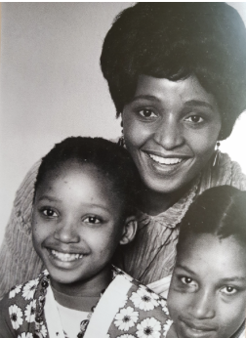In the 1960s, with Nelson safely stashed away in prison, the South African police made it a point to go after his young family with a brutal vengeance. A typical nighttime police raid, as summed up by Winnie herself (<https://www.sahistory.org.za/people/winnie-madikizela-mandela>). *“…that midnight knock when all about you is quiet. It means those blinding torches shone simultaneously through every window of your house before the door is kicked open. It means the exclusive right the security branch has to read each and every letter in the house. It means paging through each and every book on your shelves, lifting carpets, looking under beds, lifting sleeping children from mattresses and looking under the sheets. It means tasting your sugar, your mealie meal and every spice on your kitchen shelf. Unpacking all your clothing and going through each pocket. Ultimately, it means your seizure at dawn, dragged away from little children screaming and clinging to your skirt, imploring the white man dragging Mummy away to leave her alone.”[xvi]*

Alas, Winnie’s “phoenix” did ***not*** rise.

**Despite Familial Failures …**

Since Mandela was so multi-dimensional, the personal and the political were bound to come to blows. A political visionary being pulled forward by some unseen image of a better future for black South Africans, at the same time, his growing, patchwork family. Could he integrate the two? Not in the early years. Not until almost the end, in fact.

His *extraverted* personality was by all accounts that of a chameleon: iridescently magnetic—his ‘charm offensive’ could win over even outspoken enemies—but his *introverted* self, with personal intimates, could be inscrutably distant. He seemed to swing back-and-forth almost without missing a beat!

*The Guardian* reporter, David Beresford, commented on Mandela’s enigmatic character during his 27 years behind bars, emphasizing that he never overtly acknowledged any alleged ‘crimes against the State’, always insisting that he and his Freedom Fighters were ***political*** prisoners, not just the ‘garden variety’. They were paving the way for a new anti-apartheid society.

However, within the interior confines of his conscience, Mandela, the man, seemed to have been “haunted by a sense of personal failure despite his undoubted public triumph”. He himself cited “the abandonment of his family” as his greatest shortcoming~~.~~

**… yet the undeniable “defiance of Mandela’s human spirit”**

***“Some people are broken by prison; others are made by it … but I knew that If I didn’t leave my bitterness and hatred behind, I’d still BE in prison.”***

Nelson, of course, was made by it. Tempered. He emerged “mature.” That is part of his greatness.

*Caption. In the 2x2 meter cell in section B of Robben Island*

*Prison, in which Nelson Mandela was held for 18 years.*

**Mandela’s “Spiritual Pivot”**

***Hitting bottom.*** *Two of the hardest blows for Mandela came, first with the 1968 death of his mother—he was not allowed to attend her funeral—and then with the 1969 death of his eldest son, Thembi, in a car accident at age 24, both while Nelson was in prison. The authorities coldly refused to provide any details; nor did they permit him to attend either funeral. Author David Beresford revealed that “Thembi had never once visited Mandela in prison, seemingly out of resentment” for Nelson’s divorcing his mother and first wife, in order to marry Winnie.*

*Sill, Mandela’s account of how he battled to contain his grief, with Sisulu silently holding his hand in his prison cell, provides a most moving moment in Mandela’s autobiography,* ***A Long Walk to Freedom.***

*Nevertheless, he arose even out of those ashes. How? By letting GO, by moving ON.*

***4. … to post-apartheid President!***

***Arising like a phoenix out of the “ashes” of political imprisonment, Mandela became South Africa’s first Black president in 1994.***

On 10 May 1994 Mandela was inaugurated as South Africa’s first democratically elected President. This victory had to be preceded by one of the world’s most unlikely “resurrections”.

Let us recall that the victorious finale of Africa’s “long walk to freedom” began more than four years earlier, on 11 February 1990, when Mandela was released from prison and gave his first speech as a free man at Cape Town City Hall, beginning ...

*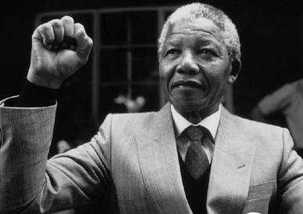****“Amandla! Amandla! i-Afrika, mayibuye!” (Power! Power! Africa, it is ours!)*** *“Friends, comrades, and fellow South Africans, I greet you all in the name of peace, democracy and freedom for all. I stand here before you not as a prophet but as a humble servant of you, the people. Your tireless and heroic sacrifices have made it possible for me to be here today. I, therefore, place the remainning years of my life in your hands.” 11 February 1990*

Thus, “Mandela’s vision and political victory not only marked a turning point in the history of his own country; it also inspired people around the world with his message of forgive-ness and reconciliation. His words paved the way for a new era of democracy and equality in [*South Africa*](https://fastercapital.com/keyword/south-africa.html) and became a symbol of hope for [*oppressed people*](https://fastercapital.com/keyword/oppressed-people.html) everywhere.”

True to his promise, Mandela stepped down in 1999 after one term as President. He continued to work with the Nelson Mandela Children’s Fund he set up in 1995 and established two other philanthropic foundations against poverty and HIV/AIDS.

Mandela’s second wife, Winnie—like most “normal mortals”—was not strong enough to withstand the pressures of separation, imprisonment and solitary confinement, all because of her husband’s anti-apartheid activism. She succumbed infidelities and corruption. In 1996 came their divorce.

**Late Life “Blooming”**

But two years later—on his 80th birthday in 1998 no less!—he married Graça Machel, his third wife and widow of the former president of Mozambique. He said, *"I don''t regret the setbacks I’ve had because, late in my life, I am blooming like a flower.”* He had cultivated that gift of letting go of the past without overwhelming regrets.

**… and Regrets.** But it was not quite over yet. In 2005, Mandela’s only surviving son, Makgatho, died of AIDS. That disease still being heavily stigmatized in Africa, he was the first African leader to acknowledge losing a family member to this disease. Were his losses at last over? Not quite.

If not deaths, then squabbles within his extended family. He attributed this to his absence during his activist decades in prison. According to his official biographer, Charlene Smith, *“In prison he felt the guilt of a workaholic, absent husband and father who had traveled often, neglecting those closest to him for the sake of the struggle against apartheid. He spent the rest of his life trying to make up for it.”*

*But, alas, o*ne never***can.*** The moment is ***gone.***

***“Mandela was a man. A very great man,***

***but his weak point was his family,”***

*- Official Biographer, Charlene Smith, 2011*

**When the Phoenix finally Arose: Mandela’s Lacks and Legacies**

This book’s symbolism flies on the wings of the mythical Greek phoenix that is prophesied to “arise out of the ashes” of its former incarnation. Thus, the phoenix represents “transformation, strength and renewal”. A long-lived, brightly-plumed bird, it symbolizes a creature newly born out of the ashes of something that has been destroyed.

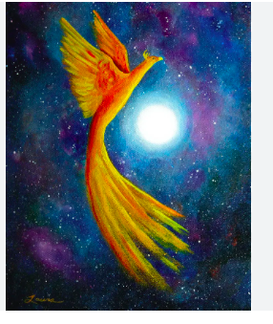Associated with the sun, the phoenix obtains new life by arising from the ashes of its predecessor, from the cloud of darkness, from its own sacred ashes. Thus, this image shows the phoenix arising from the flames as a rebirth, victorious over al life challenges and former defeats; a rebirth from the ashes of the past with its life-regenerating resilience.”

Associated with the sun, the phoenix obtains new life by arising from the ashes of its predecessor, from the cloud of darkness, from its own sacred ashes. It applies to people’s live, too.

**Lacks**. Despite fathering six children from two of his three wives, what Mandela had to do *without* was the ***everyday intimacy*** with his family, which resulted in a certain reserve and distance on his part, even to those closest to him. Even his biographer, Richard Stengel, said of him that, despite his “golden, luminous presence” and ability to charm all who experienced his aura, that “he was cool with intimates”. A protective “carapace” perhaps, that was the price of nearly three decades of imprisonment. The scars remained.

**Legacies**. And yet there are his ***lasting legacies*.** Nelson Mandela’s *“successful struggle against South Africa’s apartheid system of racial segregation and discrimination made him a global symbol for the cause of human rights and earned him the Nobel Prize”*, and yet he did not cling to power but voluntarily resigned after a single presidential term in 1999.

***From the Inspiring Aura …***

*“Nelson Mandela was a civil rights hero and arguably one of the greatest African leaders in history. He led a resistance movement, spent years behind bars unjustly and served as the President of South Africa. His life’s work was instrumental in abolishing apartheid and improving race relations. Not only was he a champion for justice and peace in his own country but also around the world. In 2009, the United Nations declared July 18th ‘International Nelson Mandela Day’. An examination of Nelson Mandela’s childhood contextualizes his legacy, both honoring and* **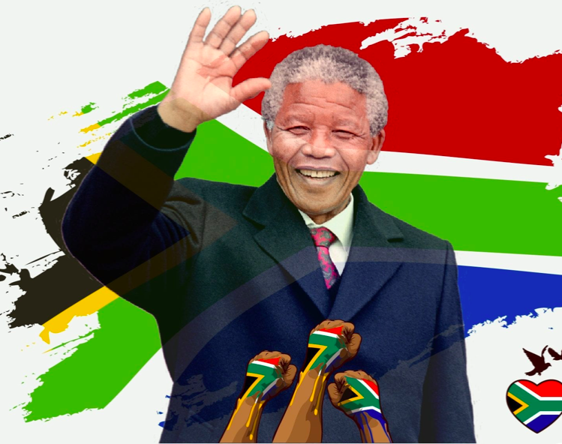***humanizing the man who contributed to the development of democracy and human rights around the globe.”*

*Source: https://borgenproject.org/nelson-mandelas-childhood-2/*

***… to the old-and-wise reflective. “What counts in life is not the mere fact that we have lived. It is what difference we have made to the lives of others.” - Nelson Mandela***

**Nelson Mandela. Part 2. “Lessons on Life” Synopsis** (R. Stengel)

*When South African Freedom Fighter Nelson Mandela was accused of high treason and thrown in prison in 1962, people thought they’s seen the last of him. They even predicted that he and his accomplices would be hanged … but that didn’t happen. Twenty-seven years later, the “phoenix” arose out of those ashes.*

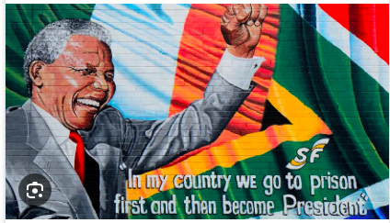Clearly, that man who entered prison in 1962 at age 44 was an iconically different one than the man who emerged in 1990 at age 71. As he said of himself, “I came out **‘mature’.**” Stengel asserts that “the 27 years Mandela spent in prison became the crucible that both hardened him and burned away all that was extraneous. Prison taught him self-control, discipline and focus—the things he considered essential to leadership—and it taught him how to be a full human being.”

What follows is a few lessons we all can learn … ***without*** having to go to prison! Here the Commander-type’s Abridged Pocket Edition “Cheat Sheet to Success”! Can you, the reader, cite one personal example for each of the ‘lessons’ below in which you PRACTICED what Mandela PREACHED? And served as role-model?

1. **”Show courage in the face of fear. Fake it til you make it!”** Courage is sometimes like the Cowardly Lion in “The Wizard of Oz”. It’s a façade we don to convince *others* that we’re brave when actually we may be terrified! Mandela used this ploy often—once at only nine when he moved to the Xhosa ‘royal court’ after his father died. The most memorable time was when he was sentenced to life imprisonment on Robben Island after the 1962 Rivonia trial. He was devastated but didn’t show it; others were looking to him as an example and he provided it. So can we.
2. **“Chill … be a cool “Commander/Advocate” MBTI Type.** Mandela evolved… and how! He himself said, *“I was very radical as a young man. I have mellowed.”* He transformed his *own* temperament by learning to “think, analyze, *then* act.” He thus became a true leader with unswervingly calm integrity.
3. **“Lead from the Front.”** A leader has to be *seen* to be leading; on the front lines and right from the get-go. One must stand up for oneself. Mandela did this even boldly in the 1960s Rivonia Trial, all but ***daring*** the government to hang him by boldly asserting, *“I AM guilty of fighting for human rights and liberty; I AM guilty of fighting unjust laws; I AM guilty of fighting for my own oppressed people… an ideal for which I am prepared to die. When faced with the inevitable, why wait?****”***
4. **“Lead from the Back.”** There’s a trick to this: *“when you defer to others, listen to their opinions and appear to invoke them, you increase their allegiance to you.”* Yes, that’s what the man said. Thembu King Jongintaba, who “adopted” nine-year-old Nelson after his father died, became his boyhood role model, but the king ruled, not by decree, but by popular “town-meeting-style”. For, unlike America or Europe, the African model of leadership is ***ubuntu***—the idea that people are empowered by others and actually become their “best selves” through unselfish interactions. (P. 81) Democracy in practice. If you reach the results you want in a *harmonious* way, it’s good for everyone!
5. **“Look the Part.” You’re so vain?! Fine. Create a signature style!** Before such concepts existed, Mandela was a genius at ***“impression management”.*** Slim and fit, he realized innately that appearances *are* important. And let’s not forget Mandela’s SMILE. Symbolizing “warmth and wisdom, power and generosity, understanding and forgiveness”, in the context of the pioneering 1990s elections, biographer Richard Stengel described his smile as the “political Prozac” for a nervous South African electorate. It ***worked!***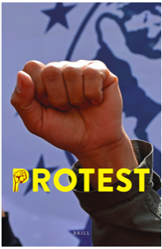

**Me in J’burg. A personal aside.** Yes, I was there, too, back in the 197Os as very much the European fair-haired blonde with my new Austrian military husband. And did we ever *feel* it—apartheid in practice! Segregation of everything from busses to bathrooms. Blacks stepped off the curb and into the street to let the two of us pass, but you couldn’t miss their envious glances, their vengeful looks, their simmering hatred. It scared us so much that we cancelled our further journey to Cape Town and scurried back to “edelweiss” Austria!

1. **“Have a Core Principle. Stick to it!” Equal rights and justice for all.** That was it. No more; no less. In the South Africa of the 1980s and 1990s, that meant the end of apartheid and every means to that end was on the table. Mandela was an ***idealistic pragmatist*** who got things done. And he learned first-hand that a when conditions changed, you had to change ***yourself*** and your tactics in order to succeed.
2. **“See the Good in Others.”** At the outset, give others the benefit of the doubt … and see what they do with it. Mandela was persuaded that “seeing the good in others might actually make them better”. Even life in prison broadened his perspective when he realized that the warders and jailers on Robben Island were both the ***victims*** *of the system and* ***perpetrators*** *of it.* Mandela chose to take the emotional risk of consciously trusting others.
3. **“Know your Enemy.” Speak his language … literally.** Cultivate his strengths. And exploit his weaknesses. When he founded “Spear of the Nation”, Mandela had to go underground, becoming the “Black Pimpernel” and South Africa’s most wanted man. But at the same time, he was learning Afrikaans, the “language of the oppressor”, even reciting its poetry. “It’s obvious,” he said. “When you speak Afrikaans, you know, you go straight to their ***hearts!”*** Knowing one’s enemy could also—perhaps in the long run—make him into a friend.
4. **“Keep your ‘friendly’ Rivals Close.”** Another tactic that Mandela used to his advantage, especially as he himself grew older and younger politicians might look for ways to upstage or unseat him: he kept an especially close eye on the younger revolutionaries because he recognized his own earlier immaturity, impatience, impulsiveness and volatile aggression in them. Plus, Mandela himself was not immune to flattery, glamour and wealth. So the “old man” kept these young guys close, even traditionally holding hands with them in public. Making them feel “indispensable” was actually “shrewd political stagecraft”, helping to keep them loyal when Nelson went on his charm offensives.
5. **“Know when to say ‘No’.”** Let’s not forget that “***NO*** is a complete sentence.” As author Richard Stengel reminds us, Mandela was “not a man of maybes.” He was clear and definitive, deciding sooner rather than later and not waffling. Even though he could not control many outcomes during his 27 years in prison, but the power of a positive “No” was always an option.
6. **“It’s a Long Game.”** Do you know anyone who has spent 27.5 years in prison 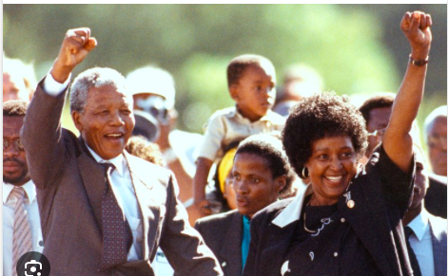… and come out the ***better*** for it? To my knowledge, Nelson is the ***only*** one. He had to learn ***“delayed gratification”*** the hard way. In his solitary cell. On an island far from loved ones. Stewing in his impatience juices til he could ennoble them. He learned that, in most cases, urgency is an ***illusion.*** He also learned that “it’s not the *velocity* of a decision but the *direction* of it” that makes the difference. He thought in terms of history and, along the way, taking that “l-o-n-g walk to freedom”, he had to alter deeply held convictions. As Stengel points out: we need to stay the course; the ***whole*** course.
7. **“Love makes the Difference.”** *”How long do you have to know someone to fall in love?”* someone once asked Mandela. *“One moment can be long enough,”* he answered. With Winnie; he saw her at a bus stop and that was it. Nelson was a romantic at heart, but, as an absentee husband and father, sacrificing love and family for the sake of a “higher calling” was perhaps his *greatest* sacrifice.

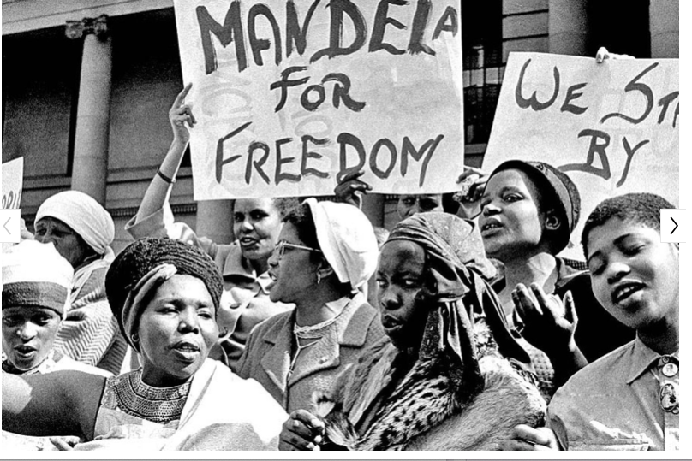*“Protestors demonstrate in Johannesburg, South Africa, on 16 August 1962, demanding Mandela’s release after his second arrest. His wife, Winnie, whom he had married in 1958, joined the protests. Mandela was sent to a penal colony off Cape Town where he spent 13 years laboring in a lime quarry.” Source: Los Angeles Times, 6 December 2013. Photo, Dennis Lee Royle, AP.*

His first marriage to Evelyn Mase, a Jehovah’s Witness, failed because she could not condone her husband’s violence. Later, his second marriage to the 16-years-younger Winnie Madikizela failed due to separation. Mandela suffered acutely from Winnie’s infidelities. “Nobody wanted to tell the old man”, Stengel confides, who had taken refuge in idealized love. But nothing really worked and Nelson himself had to be the one to file for divorce, which was finalized in 1996. But two years later—on his 80th birthday!—he married Graça Machel (52), the widow of Mozambican revolutionary leader, Samora Machel, and a political-and-women-and-children’s rights activist in her own right. This marriage held and gave him his long-sought love until his death in 2013. She was by his side.

1. **“Moving on is Leading, too.”** How many leaders cannot let GO? **Most** of them, I’d venture; power becomes an obsession. Mandela was different. He clearly intended only one five-year term (1994-1999) in office and he abided by that. Stengel compares him to George Washington who also refused to be crowned “King of America” and, although he could have stayed on for life, voluntarily retired after only two terms. After South Africa’s ‘long walk to democracy’, Mandela saw his real job as “setting the course, not steering the ship” and he stepped aside in order to do so.
2. 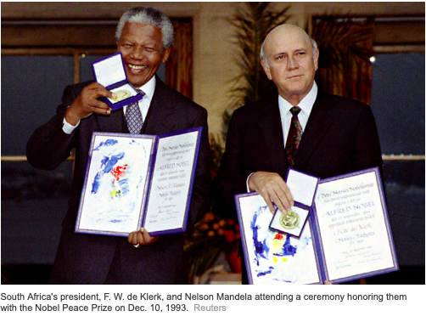**“It’s always Both.”** Well, for most people, it isn’t: it’s either / or. But Mandela strove to be wide-ranging and inclusive wherever possible. Along with Walt Whitman, he might well have said, *“Do I contradict myself? Very well then, I contradict myself, (I am large, I contain multitudes.)”* Mandela’s long life in politics, spiced by extreme experiences, gave him an unprecedented “window” into “the intricate spider’s web of human motives!. He used it in seeking to find compromise and reconcile opposing sides.
3. **“Plant your own Garden. Share the Harvest.”** Finally, in the final years of his long imprisonment as it became clear that he would be released, he turned to something creative and life-affirming: planting a simple vegetable garden on the prison grounds and sharing his harvest with both fellow inmates and warders. As he said, “*Each of us needs something away from the world that gives us pleasure and satisfaction, a place apart.”* He ***cultivated*** his garden.

**Readers’ Interactive Workbook.**

Whatever your age or current stage of life, interacting with these historic or contemporary characters can inspire your own life, calling up comparisons with the figures featured here. Take a vivid “walk down Memory Lane” and recall challenges that you faced—whether you overcame them or just barely survived with bruisingly useful “lessons learned”. This can help you rev up your right-now resilience. *Dare to explore Nelson Mandela’s unique Way.*

1. Nelson Mandela, originally named **“Rolihlahla”**—which means *i.a.* “trouble-maker”—really ***was*** one! And how! He ignited the spirit of freedom and equality in an entire nation of suppressed South African blacks. **Do you have a nickname that perfectly captures *your* personality? What is it? Who gave it to you and why?** If not, give *yourself* one! **Are you good with it?**
2. One’s family is both cocoon and crucible; it’s the intimate environment into which one is born and may contain ALL of the ingredients for a great life—or *none* of them. Despite poverty, ubiquitous illiteracy and racial discrimination, it turns out that the “Troublemaker” would have everything it took to achieve notoriety but also greatness … and then some. **Do you know anyone upon whom Destiny has “smiled” in such a unique way? If it’s YOU—or whomever—out with it and tell us how!!**
3. Every child needs love … and is hampered without it. Nelson, as the youngest of 13 children—his father was a polygamist with four wives—experienced love in abundance. Talk about extended family! His mother and three stepmothers doted on him as if he were their own and his half-siblings treated him as if all were full-blooded family. Nelson was the very first to attend school and, when his father died of TB at only 44, this precocious son was adopted by the Thembu chieftain who brought him up as his own. **What good fortune!! The Fates must have conspired together!!! Do you have anything in your life that suggests such synchronicity? Could you create it yourself? What would YOU have to do? Be a “troublemaker”? Or a visionary? Or both?**
4. Obedience is not enough when rulers are oppressive. From activism to rebellion. Nelson&Co went on the rampage, bombs and all! **Do you ever see violence as being justified? If so, under what circumstances? Do you think his punishment was in keeping with his alleged crimes? Why or why not?**
5. Nelson’s second crucial catalyst: prison. How 27 endless years in prison molded Mandela’s life. For most “normal mortals”, prison is a “ball-breaker” (excuse my French!). **Have you ever been in jail? What for? And for how long? What was the effect on you personally? And others close to you? Was it worth it?**
6. Nelson’s third crucial catalyst: personal loss of those nearest and dearest to him. What do you think was Mandela’s most grievous personal loss? His ‘crash landing’? **Have you ever lost someone very dearly close to you? You don’t need to talk about the details … but what did the deep-level personal results look like for you? Were you weakened or strengthened by this loss? Did, in fact, the “Phoenix rise” out of those ashes? How might you pass it on?**

***************